loss: 0.2175 - accuracy: 0.9208 - val_loss: 2.1015 - val_accuracy: 0.5190
loss: 0.1627 - accuracy: 0.9286 - val_loss: 2.5394 - val_accuracy: 0.5459
loss: 0.2582 - accuracy: 0.8984 - val_loss: 2.6441 - val_accuracy: 0.5213
loss: 0.1937 - accuracy: 0.9180 - val_loss: 2.3475 - val_accuracy: 0.5526
loss: 0.1511 - accuracy: 0.9353 - val_loss: 2.3158 - val_accuracy: 0.5749
loss: 0.2078 - accuracy: 0.9196 - val_loss: 2.0800 - val_accuracy: 0.5973

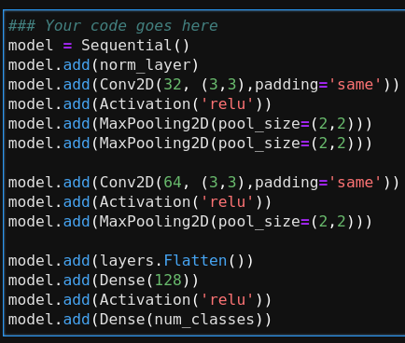
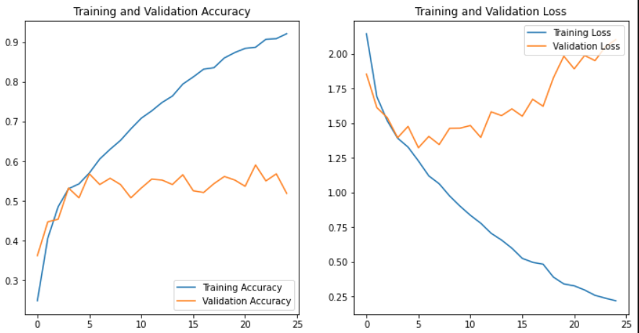
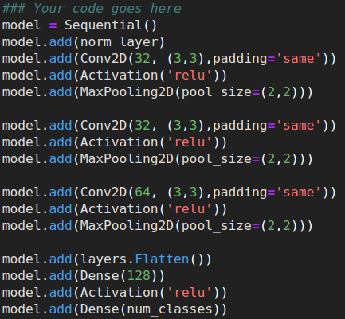
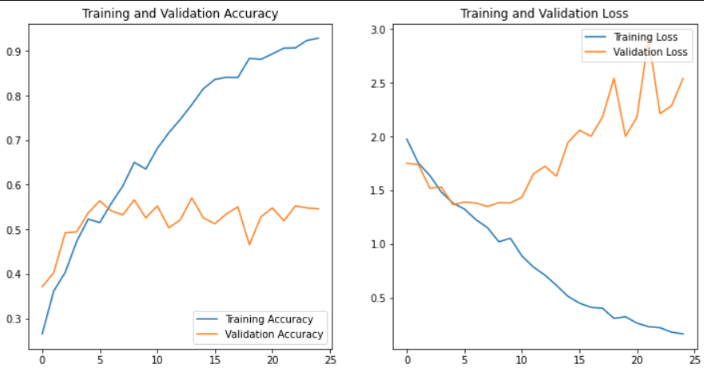
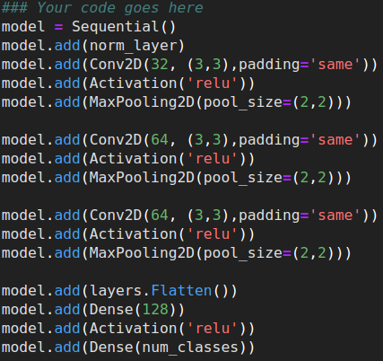
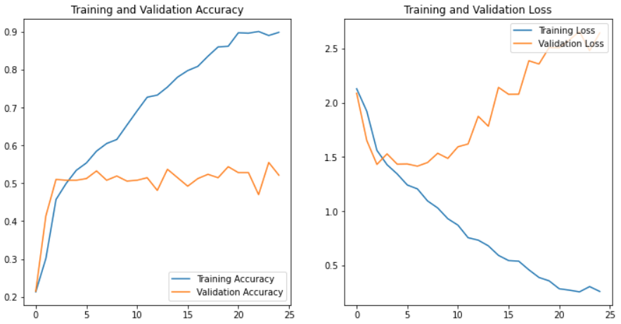
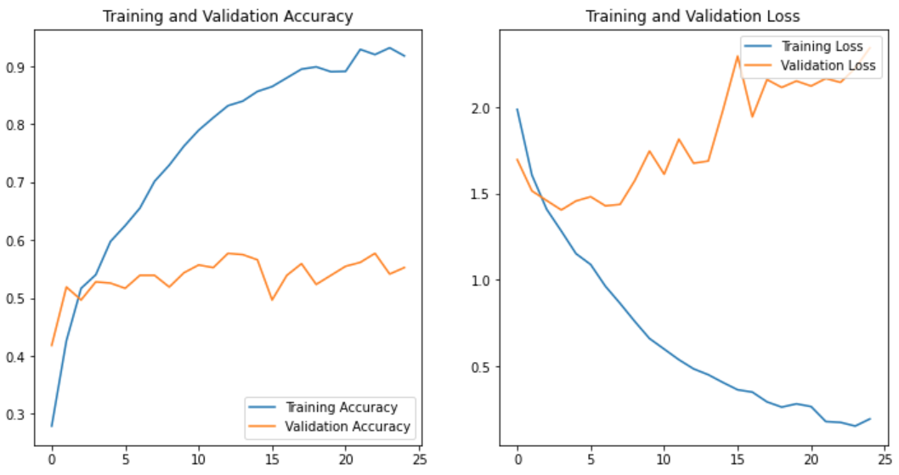
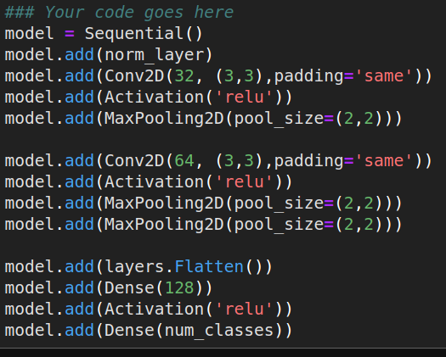
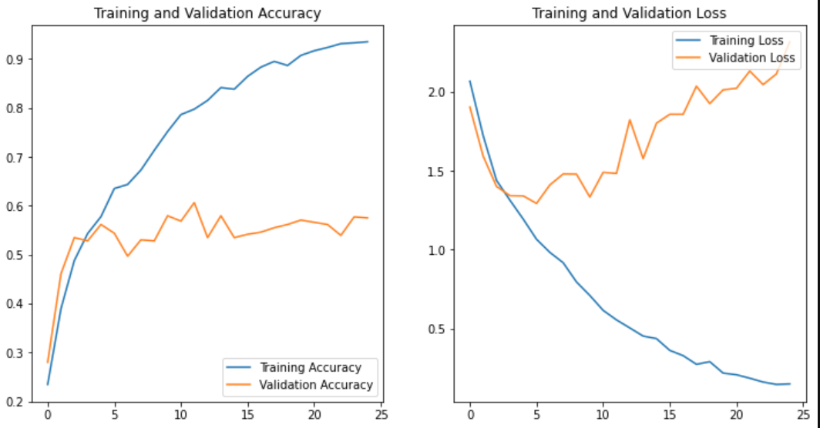
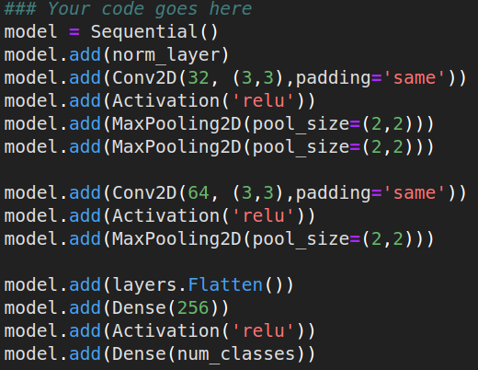
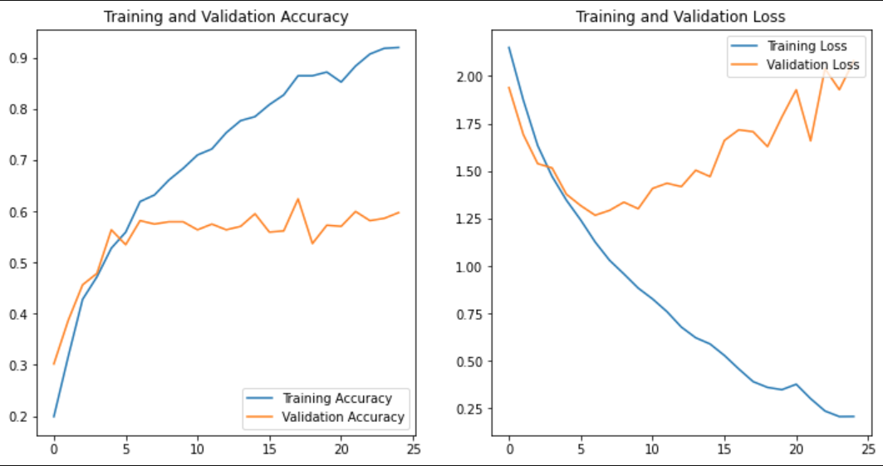
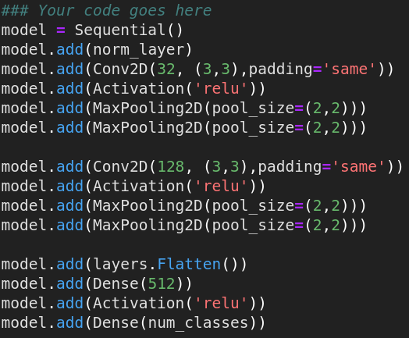
a
a

sadasd

